Health Intake Form
Name _________________________________________________________ Sex ________ Age ________ Date of Birth ________________________________
Address ____________________________________________________________________________________________________________________________
City ___________________________________________________________________ State _____________________________________ Zip ______________
Email ________________________________________________________________________ Would you like to be included on an email mailing list? __________
Home Phone _______________________ Cell Phone _________________________ Occupation __________________________________________________
Referred by _________________________________________________________________________________________________________________________
Primary Physician’s Name _____________________________________________________ Phone No ________________________________________________

Current Health
Do you exercise regularly and/or participate in any sports? _____________If yes, describe: __________________________________________________________
Have you recently suffered an injury? ____________ If yes, describe: ___________________________________________________________________________
Have you had any areas of inflammation? ____________If yes, describe: ________________________________________________________________________
Are you currently under the care of a physician? __________ If yes, explain: _____________________________________________________________________
Have you had recent surgery? _________________ If yes, explain: ____________________________________________________________________________
Allergies ____________________________________________________________________________________________________________________________
Prescribed medication(s) ______________________________________________________________________________________________________________
Vitamins/Minerals/Dietary supplements ___________________________________________________________________________________________________

Please check yes for any conditions that apply:

____ High/low blood pressure
____ Headache
____ Contact lenses
____ Allergies to oils/scent sensitivity
____ Back pain/Sciatica
____ Spinal problems
____ Osteoporosis
____ Chronic pain
____ Broken bones
____ Easy bruising
____ Skin conditions
____ Varicose veins
____ Phlebitis/Blood clots
____ Arthritis or joint disease
____ Tendonitis, bursitis, sprain, strain
____ Pregnant
____ Heart conditions
____ Diabetes
____ Seizures/Convulsions
____ Depression, Anxiety, other Psychiatric condition
____ Cancer or tumors
____ Infectious diseases
____ Auto-Immune Disorder*

(*AIDS, fibromyalgia, chronic fatigue, lupus, etc.)

Any other medical condition(s) of which to be aware? _______________________________________________________________________________
__________________________________________________________________________________________________________________________
__________________________________________________________________________________________________________________________

If applicable, describe briefly your prior experience(s) with bodywork – Type/Frequency/Consistency? _____________________________________________
Please mark any area(s) in the diagram where you are having pain or discomfort:
.
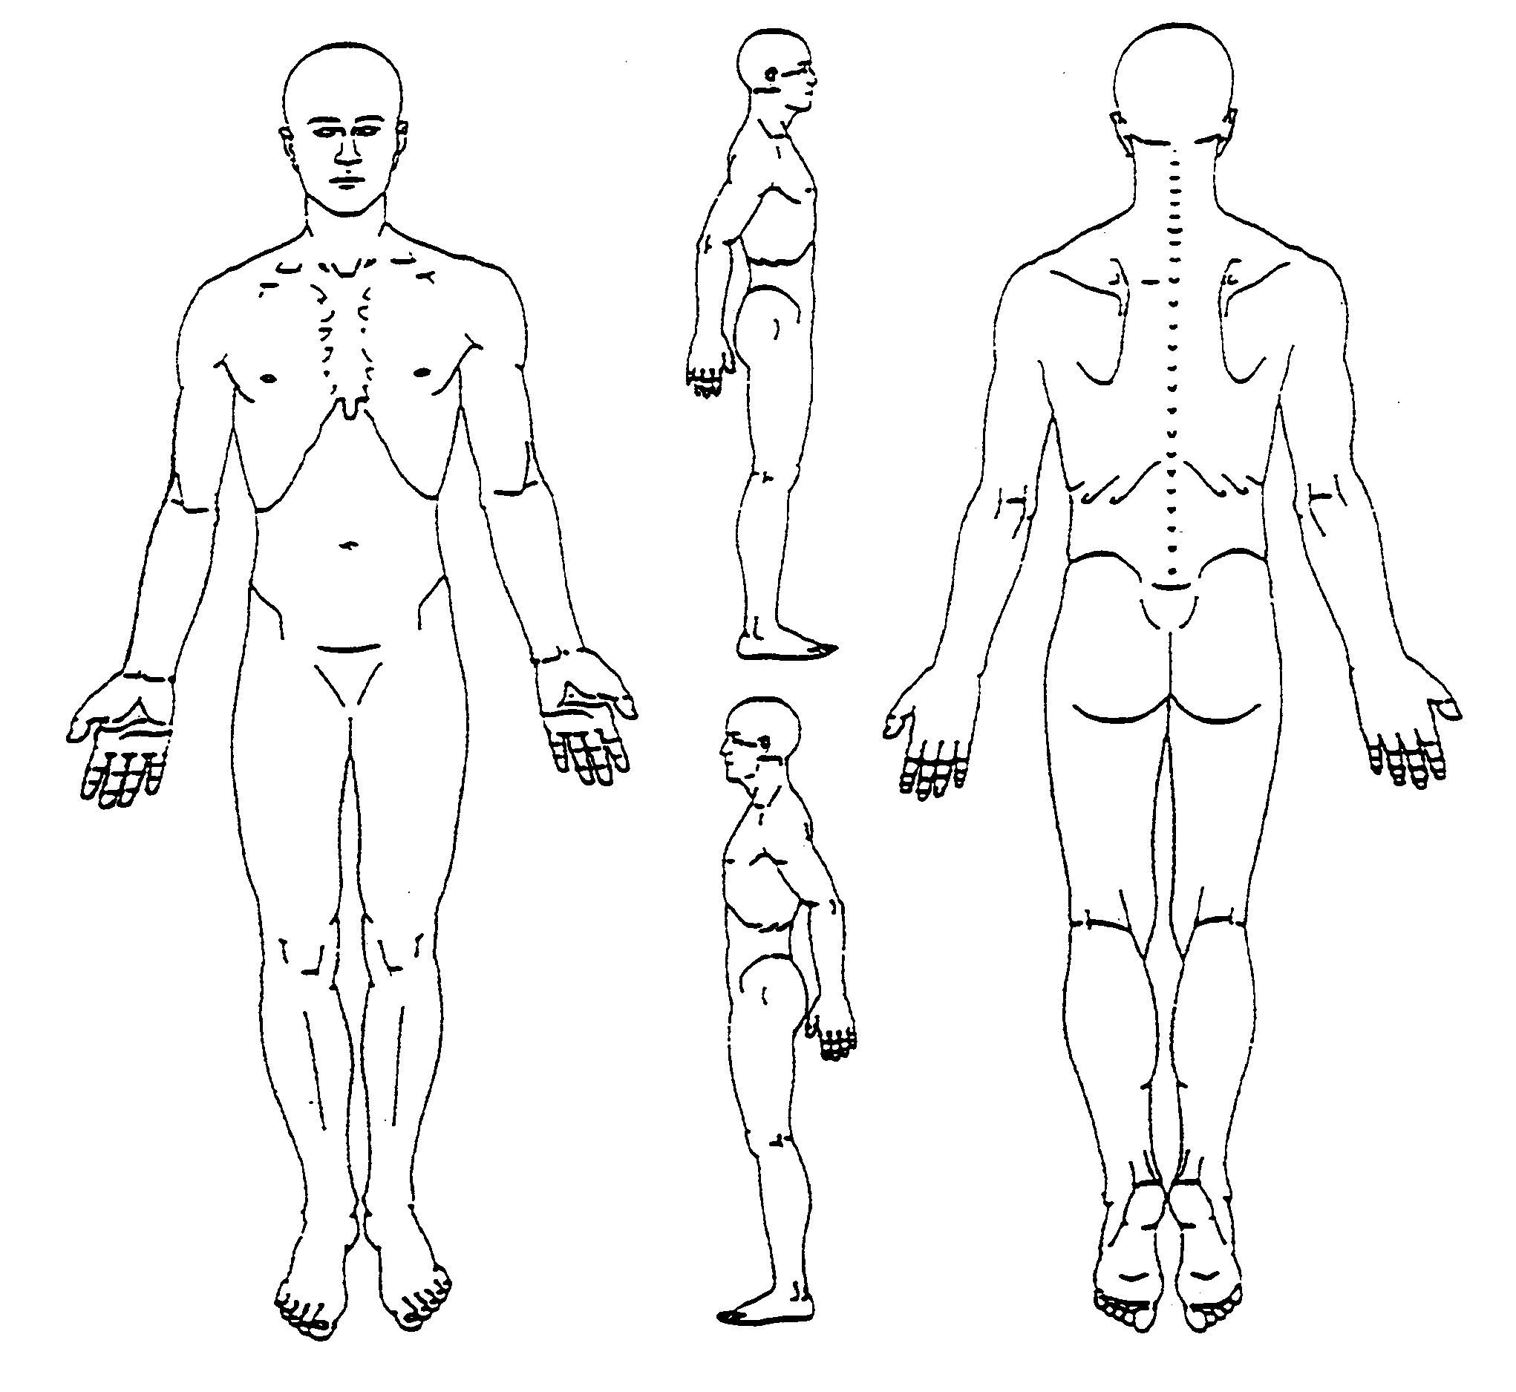
__________________________________________________________________________________________________________________________________________________________________________________________________________________

Outline your current health + wellness goals/expectations to be addressed in our session(s): ____________________________________________________________
________________________________________________________________________________________________________________________________________________________________________________________________________________________________________________________________________________________
______________________________________________________________________

By signing below, I acknowledge that I have completed this health intake form to the best of my knowledge. After a thorough review, I have discussed any/all concerns I may have regarding treatment. I understand that all of the information I’ve provided will remain confidential.

Signature _______________________________________________ Date __________

